Sample Plan for COVID-19
Exposure Prevention, Preparedness, and Response
Every construction project is different. What is feasible and appropriate for any one project depends on its size, location and other unique characteristics. This document is not intended to be a definitive statement of the protocols and procedures that are applicable to each and every project, nor are they endeavoring to provide legal or other professional advice. This document should NOT be construed as legal advice or any other expression of the scope or nature of a construction contractor’s legal obligation to provide employment and a safe place of employment to its employees, particularly under the unprecedented circumstances that the COVID-19 outbreak has created. In addition, new and better information could well supersede the information included in this document. As the situation evolves, construction contractors should continue to monitor the environment in which they are working and related developments and react accordingly.
[Name of Company] (hereinafter “Company”) takes the health and safety of our employees very seriously. With the spread of the coronavirus or “COVID-19,” a respiratory disease caused by the SARS-CoV-2 virus, the Company must remain vigilant in mitigating the outbreak. The Company is a proud part of the construction industry, which many have deemed “essential” during this Declared National Emergency. In order to be safe and maintain operations, we have developed this COVID-19 Exposure Prevention, Preparedness, and Response Plan to be implemented, to the extent feasible and appropriate, throughout the Company and at all of our jobsites. The Company has also identified a team of employees to monitor the related guidance that The OHIO Department of Health, U.S. Center for Disease Control and Prevention (“CDC”) and Occupational Safety and Health Administration (“OSHA”) continue to make available.
This Plan is based on information available from the ODH, CDC and OSHA at the time of its development, and is subject to change based on further information provided by the ODH, CDC, OSHA, and other public officials. The Company may also amend this Plan based on operational needs.
- Responsibilities of Managers and Supervisors
All managers and supervisors must be familiar with this Plan and be ready to answer questions from employees. Managers and supervisors must set a good example by following this Plan at all times. This involves practicing good personal hygiene and jobsite safety practices to prevent the spread of the virus. Managers and supervisors must encourage this same behavior from all employees.

Each project site should have a designated workplace coordinator who is responsible for COVID-19 issues and their impact at the project site.
- Responsibilities of Employees
It is critical that employees NOT report to work while they are experiencing illness symptoms such as a fever, cough, shortness of breath, sore throat, runny/stuffy nose, body aches, chills, or fatigue. Employees should seek medical attention if they develop these symptoms. If you have a specific question about this Plan or COVID-19, please ask your management or supervisor. If they cannot answer the question please contact [Title of Manager or Supervisor].
The ODH, OSHA and the CDC have provided the following control and preventive guidance for all workers, regardless of exposure risk:
Each employee must wear a face covering at all times unless a healthcare professional has advised against doing so or more protective PPE is required.
At a minimum, facial coverings (mask) should be cloth/fabric and cover an individual’s nose, mouth, and chin.
Frequently wash your hands with soap and water for at least 20 seconds. When soap and running water are unavailable, use an alcohol-based hand rub with at least 60% alcohol.
Avoid touching your eyes, nose, or mouth with unwashed hands.
Follow appropriate respiratory etiquette, which includes covering for coughs and sneezes.
Avoid close contact with people who are sick.
In addition, employees must familiarize themselves with the symptoms of COVID-19, which include the following:
- Coughing
- Fever
- Shortness of breath, difficulty breathing
- Early symptoms such as chills, body aches, sore throat, headache, diarrhea, nausea/vomiting, and runny nose
If you develop a fever and symptoms of respiratory illness, such as cough or shortness of breath, DO NOT GO TO WORK and call your supervisor and healthcare provider right away. Likewise, if you come into close contact with someone showing these symptoms, call your supervisor and healthcare provider right away.
- Jobsite Protective Measures
To protect employees and the public from the spread of COVID-19, each employer should screen its employees each day before work by following these steps:

- Enhanced Worker Education
Specialized communications and posters on the importance of frequent hand washing and hygiene, cough and sneeze protocols, along with the mandate to stay home when an employee is feeling sick or has an elevated temperature (100.4 degrees or higher). All employees must diligently observe these requirements.
- Daily Employee Screening
  - Supervisors should ask the following questions to all employees prior to entering the jobsite:
    - Have you been advised to self-quarantine due to possible exposure to COVID-19?
    - Are you having trouble breathing or have you had flu-like symptoms within the past 48 hours, including: fever, cough, shortness of breath, sore throat, runny/stuffy nose, body aches, chills, or fatigue?
  - If an employee answers “YES” to any of these questions, that employee should be encouraged to contact their healthcare provider and must stay home until:
    - they are free of fever (without the use of medication) for at least 72 hours (three full days); AND
    - symptoms have improved for at least 72 hours; AND
    - at least 7 days have passed since symptoms first began.
  - Do not require a healthcare provider’s note to validate the illness or return to work of an employee with acute respiratory illness because healthcare provider officers and medical facilities may be extremely busy and not able to provide such documentation in a timely manner.
  - The Designated Workplace Coordinator should maintain a log for all employees entering the job-site and be able to provide said log upon request from an authority. The job-site log should include the names of each person entering the job-site as well as confirmation that the above Daily Employee Screening protocol has been followed with respect to each person.
- Jobsite Visitors
  - The number of visitors to the job site, including the trailer or office, will be limited to only those necessary for the work.

  - It is recommended that all visitors wear face coverings at all time unless more protective PPE is required.

    - At a minimum, facial coverings (mask) should be cloth/fabric and cover an individual’s nose, mouth, and chin.
  - All visitors will be screened in advance of arriving on the job site. If the visitor answers “yes” to any of the following questions, he/she should not be permitted to access the jobsite:

    - To the best of your knowledge, have you, or anyone in your family, been in contact with a person that is in the process of being tested for COVID-19?
    - Have you, or anyone in your family traveled outside of the United States within the last two weeks?

    - Have you been advised to self-quarantine due to possible exposure to COVID-19?

    - Are you having trouble breathing or have you had flu-like symptoms within the past 48 hours, including: fever, cough, shortness of breath, sore throat, runny/stuffy nose, body aches, chills, or fatigue?
  - Site deliveries will be permitted but should be properly coordinated in line with the employer’s minimal contact and cleaning protocols. Delivery personnel should remain in their vehicles if at all possible.
- Social Distancing Measures - Construction jobsites are NOT densely populated work areas. Nevertheless, the following should also be taken across our industry:
  - Workers should be instructed to observe a minimum distance of six (6) feet between individuals as much as reasonably possible to increase physical space between each individual at the worksite. This includes pre‐work and post‐work events of all kinds.
  - Employers should change their jobsite communications, planning, and schedules to shrink or eliminate group gatherings. This includes minimizing or the elimination of pre‐job conferences, communal break locations, and activity that would bring a group of people together on the jobsite. Policies for material deliveries and other third‐party jobsite visits should be altered. These and other measures – which include remote work should be considered and implemented.
  - Start and end times should be staggered to allow Projects to proceed and allow more space between workers to comply with Social Distancing requirements.
  - Elevators and hoists should be limited to no more than 3 people if Social Distancing cannot be maintained with more people.
  - Occupied Buildings shall establish maximum capacity of no more that 50% of fire code occupancy limit.
- Administrative Controls - Use administrative controls, when feasible, to reduce or eliminate the risk of exposure
  - Below are sample questions for screening work assignments before sending a worker to perform construction activities in an indoor environment that may be occupied.
Screening Questions | Recommended Action
1. Is the construction work at an occupied work site essential, urgent, or emergency work? | If “yes,” proceed with a hazard assessment to determine how best to proceed while minimizing exposure for the worker. See the questions below.
2. Are there any individuals in the occupied site under quarantine or isolation due to a confirmed case of COVID-19? | Closely follow recommended infection prevention measures in the sections on Engineering Controls, Administrative Controls, Safe Work Practices, and PPE.
3. If the work is determined to be essential, urgent or emergency work, are there any individuals or contractors in the occupied site suffering flu-like symptoms to which your employees may be exposed? | Closely follow recommended infection prevention measures in the sections on Engineering Controls, Administrative Controls, Safe Work Practices, and PPE.

- Hazard Analysis – Assess the hazards to which your workers may be exposed; evaluate the risk exposure; and select, implement, and ensure employees use controls to prevent exposure. The table below describes construction work tasks associated with the exposure risk levels in OSHA’s occupational exposure risk pyramid.

Lower (caution) | Medium | High | Very High
- Tasks that allow employees to remain at least 6 feet apart and involve little contact with the public, visitors, or customers.  Note: For activities in the lower (caution) risk category, OSHA's Interim Guidance for Workers and Employers of Workers at Lower Risk of Exposure may be most appropriate. | - Tasks that require workers to be within 6 feet of one another.  - Tasks that require workers to be in close contact (within 6 feet) with customers, visitors, or members of the public. | - Entering an indoor work site occupied by people such as other workers, customers, or residents suspected of having or known to have COVID-19, including when an occupant of the site reports signs and symptoms consistent with COVID-19.  Note: Employers may consider delaying this work following the guidance below. | - Category not applicable for most anticipated work tasks.  Note: Most construction work tasks are associated with no more than high exposure risk; see the work tasks associated with lower, medium, or high risk on this chart.
- Job Site Cleaning and Disinfecting

- Routine cleaning should be performed on all frequently touched surfaces on the jobsite. This includes, but is not limited to, workstations, countertops, handles, doorknobs, gang boxes, shared tools and equipment.

I.e. Project trailers, offices and restrooms should be cleaned daily.

- Avoid using pressurized air or water spray type cleaning techniques that may result in the generation of bio-aerosols.

- Restrooms and Hand Cleaning Facilities:

  - In addition to daily cleaning, the responsible company should service portable restrooms at a least three (3) times a week.

  - Running water with soap and/or hand sanitizer should be provided in/or around all portable restrooms.

- Lunch and Break Areas

  - All common break areas, lunch and break rooms should be cleaned multiple times throughout the work day

  - Do not allow individual to congregate in lunch or break areas.

  - No communal food should be permitted on the jobsite until further notice, i.e. donuts, pizza, buffets, etc.

- Do not use a common water cooler. Provide individual water bottles or instruct workers to bring their own.

- Tools & Equipment

  - Tools and equipment should be cleaned daily

  - Sharing off tools or any multi-user electronic devices and accessories should be prohibited, e.g. iPads, laptops, hand-held radios, computer stations, etc.

  - Disinfect reusable supplies and equipment

- Personal Protection Equipment (PPE)

  - Sharing of personal protection equipment (PPE) should be prohibited. Reusable PPE should be sanitized per manufacturer’s recommendation prior to each use. Used PPE should be disposed of properly.
  - When cleaning, use disposable gloves where appropriate and instruct employees to wash hands after removing gloves.

- Identify Specific Locations and Practices for Daily Trash - paper, hand towels, food containers, etc. Instruct workers responsible for trash removal in proper PPE/hand washing practices.

  - Clean surfaces of service/fleet vehicles, steering wheel, gearshift, instrument panels, etc; use aerosol sanitizers inside closed cabs.

  - [Additional Jobsite Safety Precautions Include: Additional Precautions that May be Appropriate for Specific Companies, Business Operations or Projects].

- Personal Protection Equipment
  - Each employee must wear a face covering at all times unless a healthcare professional has advised against doing so or more protective PPE is required.
    - At a minimum, facial coverings (mask) should be cloth/fabric and cover an individual’s nose, mouth, and chin.
    - Employers must provide written justification, upon request, explaining why an employee is not required to wear a facial covering in the workplace.
  - Employees should be required to wear gloves to limit transfer and/or sharing among employees.
  - Where employees necessarily must work in closer contact than the Social Distancing requirements, heightened PPE should be required, including, approved protective masks, gloves, and clothing.
- Jobsite Exposure Situations

Separate sick employees who appear to have acute respiratory illness symptoms (i.e. cough, shortness of breath) upon arrival to work or become sick during the day should be separated from other employees and be sent home immediately. Contact the local health district about suspected cases or exposures.

Know that the health and safety of our members and their families is always job number one. Responsible contractors and their skilled labor force will continue to provide a vital service to our State.

- Employee Tests Positive for COVID-19
An employee who tests positive for COVID-19 will be directed to self-quarantine away from work. Employees that test positive and are symptom free may return to work when at least seven (7) days have passed since the date of his or her first positive test and have not had a subsequent illness. Employees who test positive and are directed to care for themselves at home may return to work when: (1) at least 72 hours (3 full days) have passed since recovery;³ and (2) at least seven (7) days have passed since symptoms first appeared. Employees who test positive and have been hospitalized may return to work when directed to do so by their medical care providers. The Company will require an employee to provide documentation clearing his or her return to work.
- Employee Has Close Contact with an Individual Who Has Tested Positive for COVID-19
Employees who have come into close contact with an individual who has tested positive for COVID-19 (co-worker or otherwise) will be directed to self-quarantine for 14 days from the last date of close contact with that individual. Close contact is defined as six (6) feet for a prolonged period of time.
If the Company learns that an employee has tested positive, the Company will conduct an investigation to determine co-workers who may have had close contact with the confirmed- positive employee in the prior 14 days and direct those individuals who have had close contact with the confirmed-positive employee to self-quarantine for 14 days from the last date of close contact with that employee. If applicable, the Company will also notify any sub-contractors, vendors/suppliers or visitors who may have had close contact with the confirmed-positive employee. If an employee learns that he or she has come into close contact with a confirmed-positive individual outside of the workplace, he/she must alert a manager or supervisor of the close contact and self-quarantine for 14 days from the last date of close contact with that individual.
- OSHA Recordkeeping
If a confirmed case of COVID-19 is reported, the Company will determine if it meets the criteria for recordability and reportability under OSHA’s recordkeeping rule. OSHA requires construction employers to record work-related injuries and illnesses that meet certain severity criteria on the OSHA 300 Log, as well as complete the OSHA Form 301 (or equivalent) upon the occurrence of these injuries. For purposes of COVID-19, OSHA also requires employers to report to OSHA any work-related illness that (1) results in a fatality, or (2) results in the in-patient hospitalization of one or more employee. “In-patient” hospitalization is defined as a formal admission to the in-patient service of a hospital or clinic for care or treatment.
OSHA has made a determination that COVID-19 should not be excluded from coverage of the rule – like the common cold or the seasonal flu – and, thus, OSHA is considering it an “illness.” However, OSHA has stated that only confirmed cases of COVID-19 should be considered an illness under the rule. Thus, if an employee simply comes to work with symptoms consistent with COVID-19 but is not a confirmed diagnosis, the recordability analysis is not necessarily triggered at that time.
If an employee has a confirmed case of COVID-19, the Company will conduct an assessment of any workplace exposures to determine if the case is work-related. Work-relatedness is presumed for illnesses that result from events or exposures in the work environment, unless it meets certain exceptions. One of those exceptions is that the illness involves signs or symptoms that surface at work but result solely from a non-work-related event or exposure that occurs outside of the work environment. Thus, if an employee develops COVID-19 solely from an exposure outside of the work environment, it would not be work-related, and thus not recordable.
The Company’s assessment will consider the work environment itself, the type of work performed, the risk of person-to-person transmission given the work environment, and other factors such as community spread. Further, if an employee has a confirmed case of COVID- 19 that is considered work-related, the Company will report the case to OSHA if it results in a fatality within 30 days or an in-patient hospitalization within 24-hours of the exposure incident.

- Confidentiality/Privacy
Except for circumstances in which the Company is legally required to report workplace occurrences of communicable disease, the confidentiality of all medical conditions will be maintained in accordance with applicable law and to the extent practical under the circumstances. When it is required, the number of persons who will be informed that an unnamed employee has tested positive will be kept to the minimum needed to comply with reporting requirements and to limit the potential for transmission to others. The Company reserves the right to inform other employees that an unnamed co-worker has been diagnosed with COVID-19 if the other employees might have been exposed to the disease so the employees may take measures to protect their own health. The Company also reserves the right to inform sub-contractors, vendors/suppliers or visitors that an unnamed employee has been diagnosed with COVID-19 if they might have been exposed to the disease so those individuals may take measures to protect their own health.

Ohio Construction Industry Standards
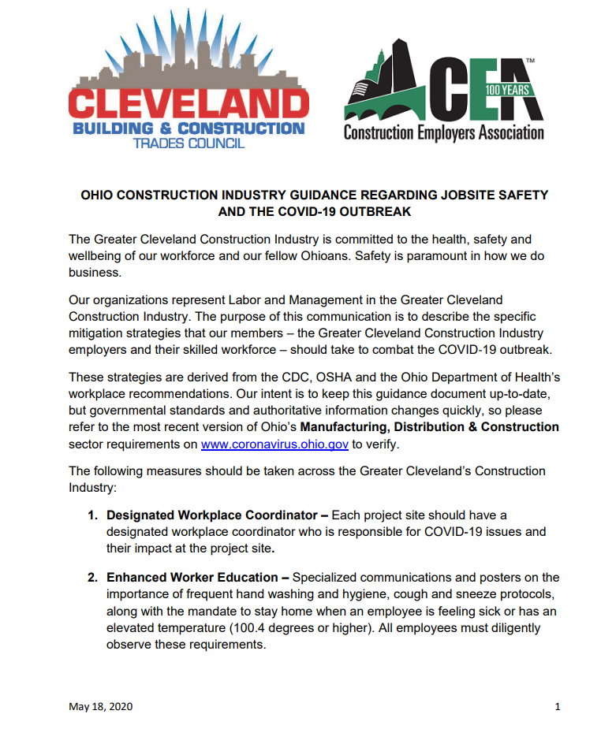
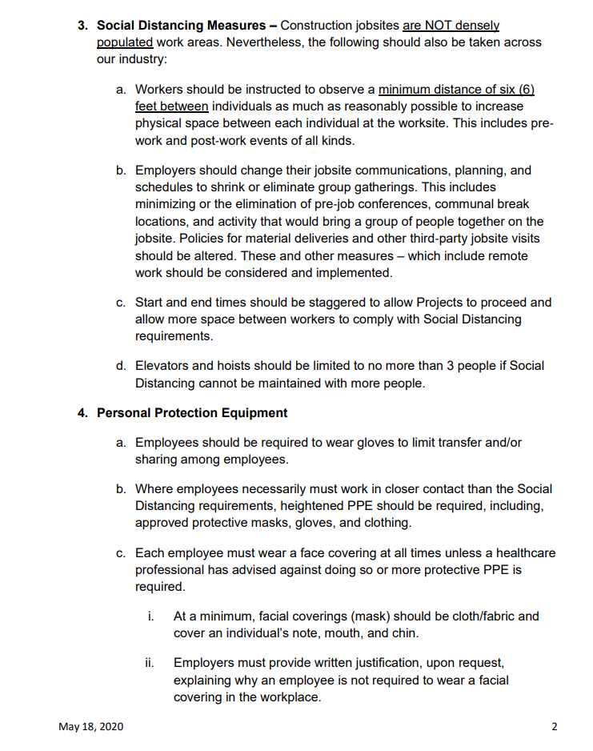
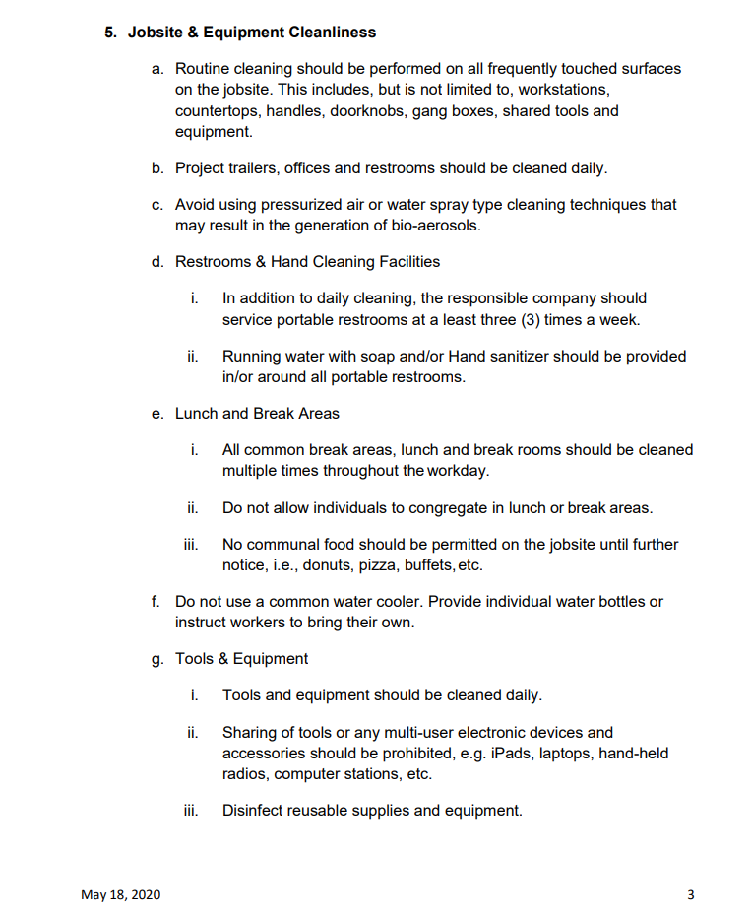
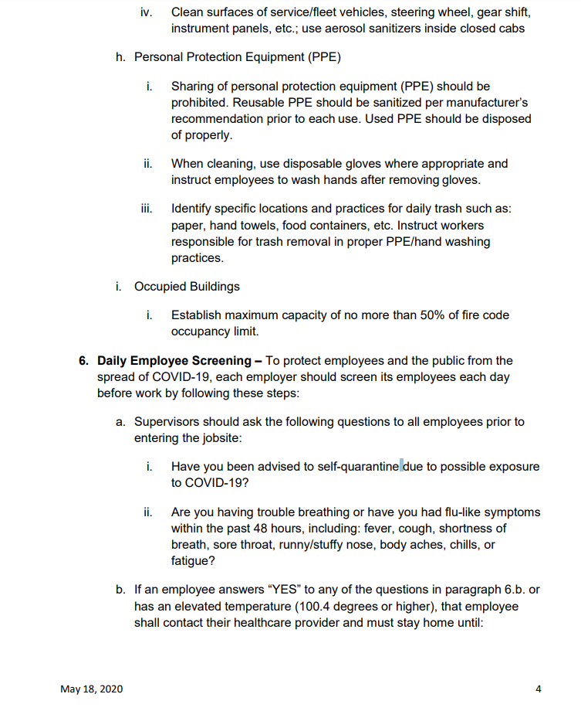
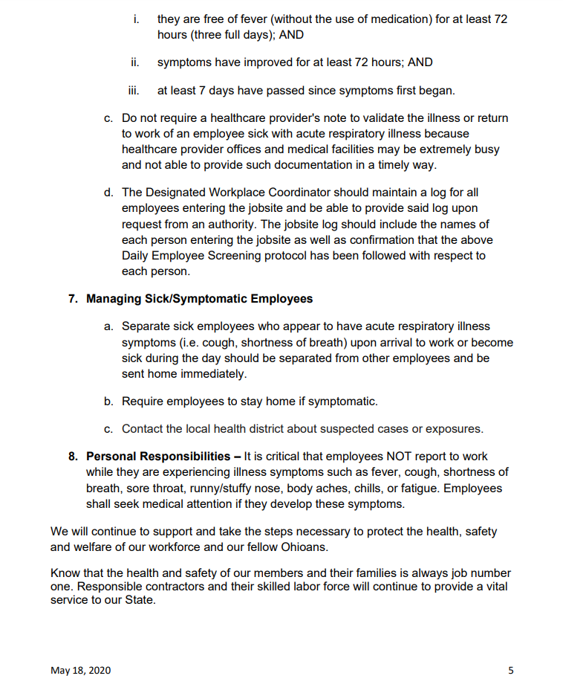
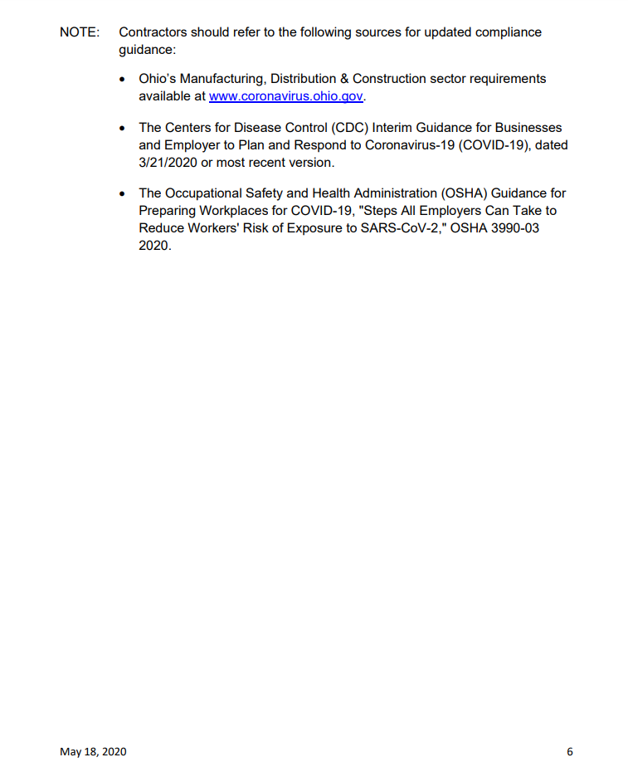

COVID-19 Toolbox
CDC- What You Need to Know
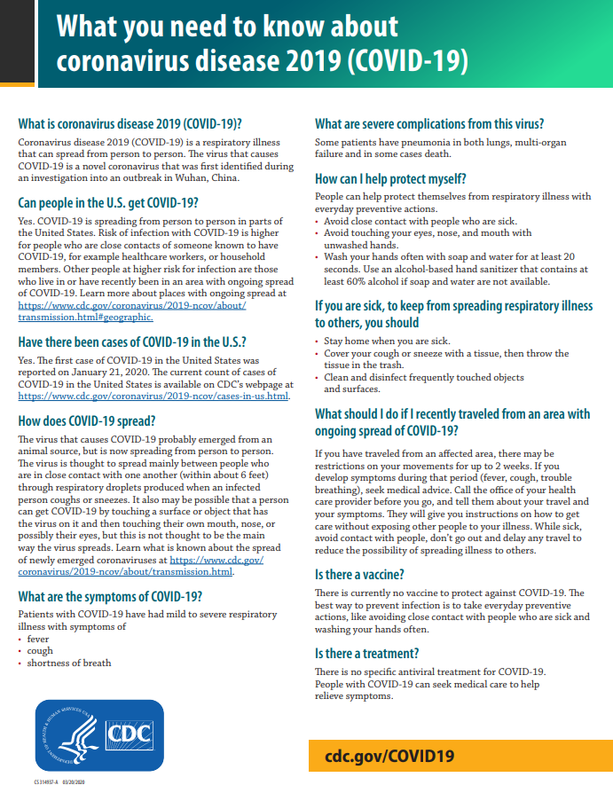
COVID-19 Toolbox
CDC- Steps to Prevent If You are Sick Page 1 of 2

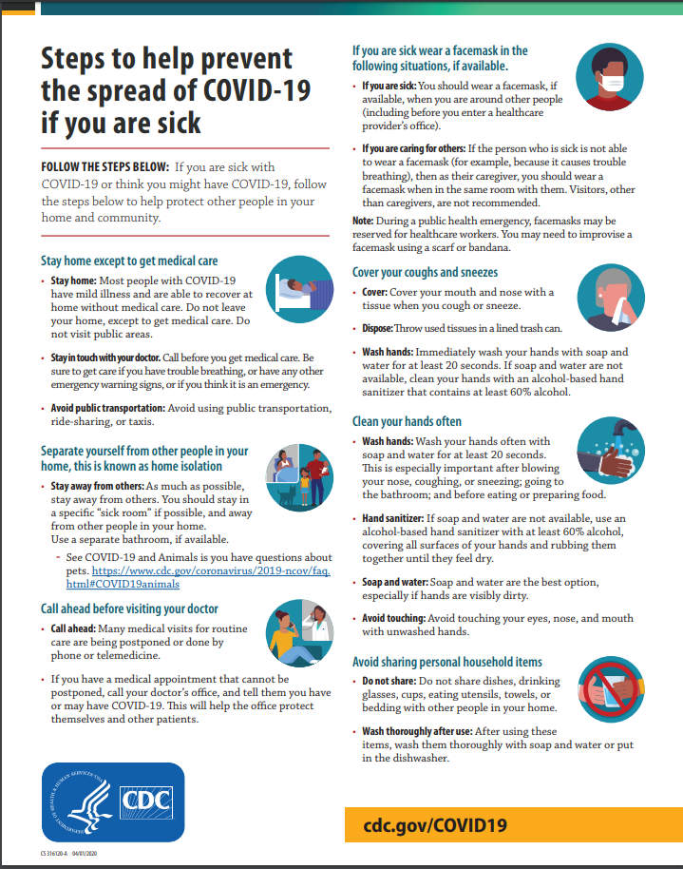
COVID-19 Toolbox
CDC- Steps to Prevent If You are Sick Page 2 of 2

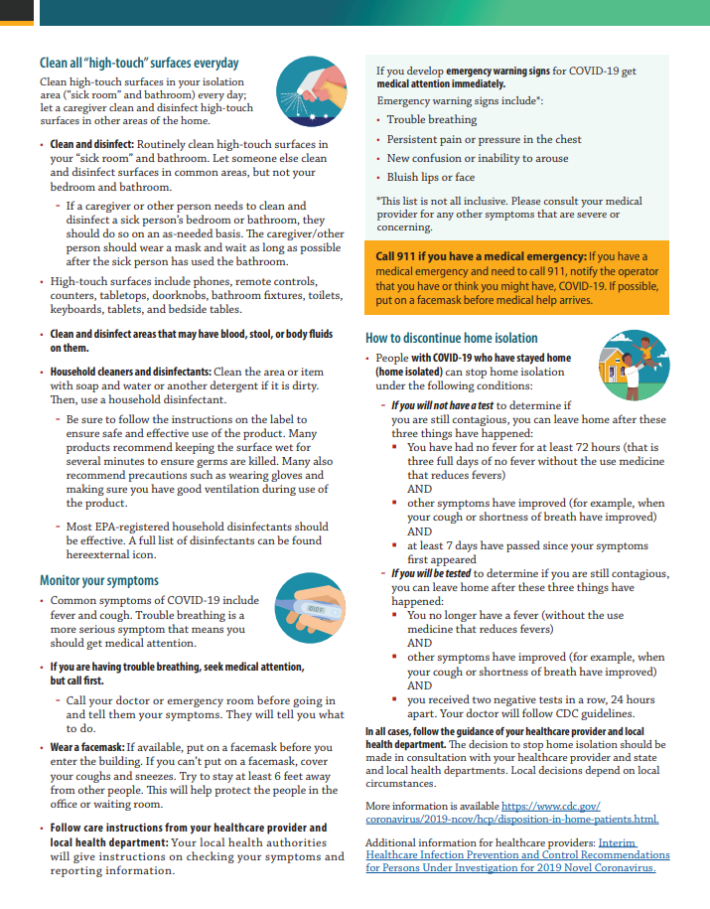
COVID-19 Toolbox
Handwashing Page 1 of 2
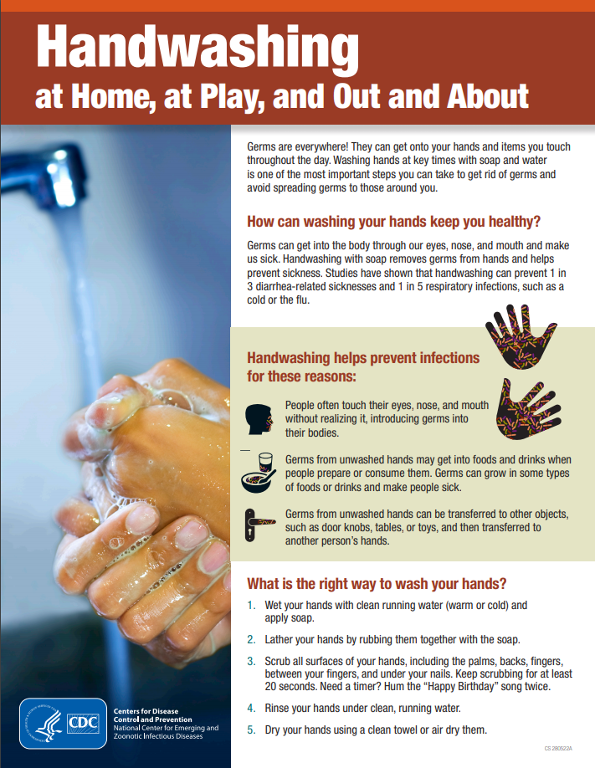
COVID-19 Toolbox
Handwashing Page 2 of 2
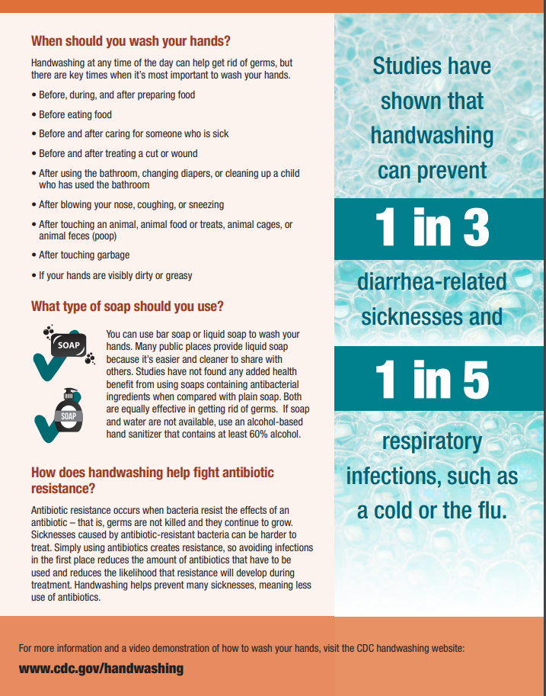

COVID-19 Toolbox
Cover Your Cough

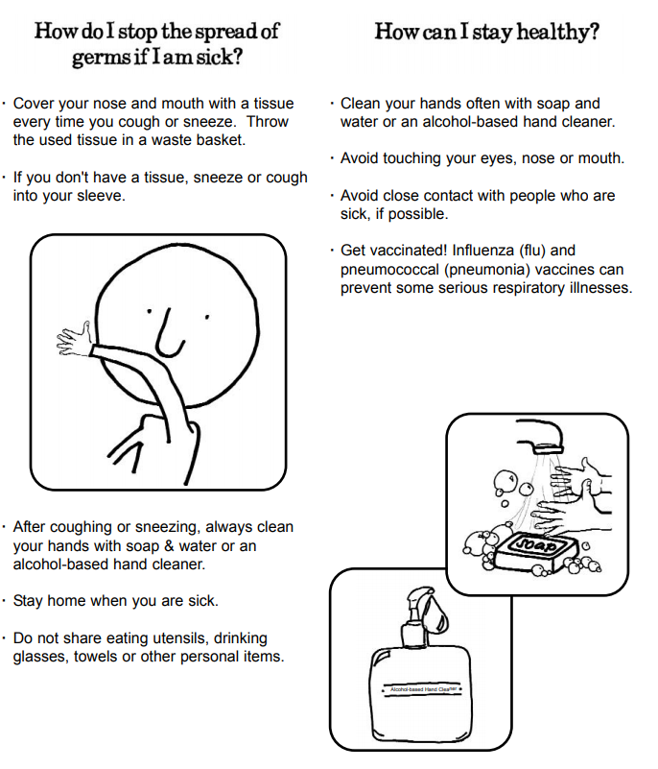

COVID-19 Toolbox
Use of Cloth Face Coverings Page 1 of 3
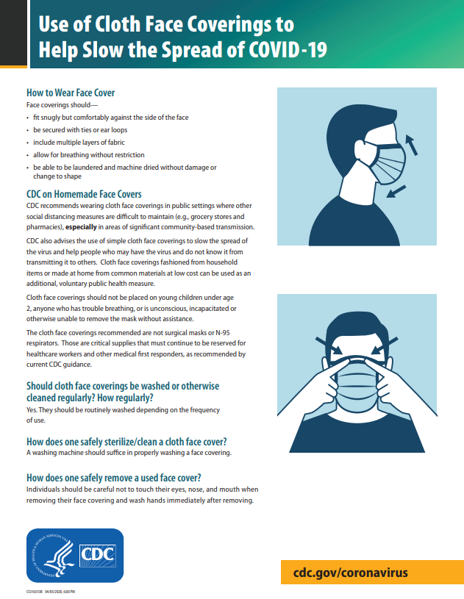
COVID-19 Toolbox
Use of Cloth Face Coverings Page 2 of 3

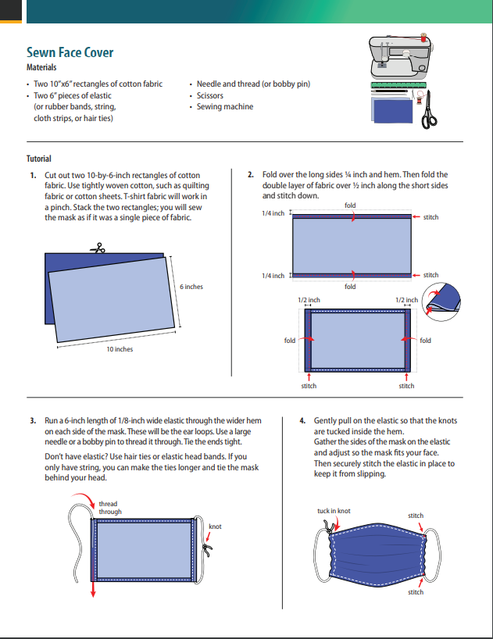
COVID-19 Toolbox
Use of Cloth Face Coverings Page 3 of 3

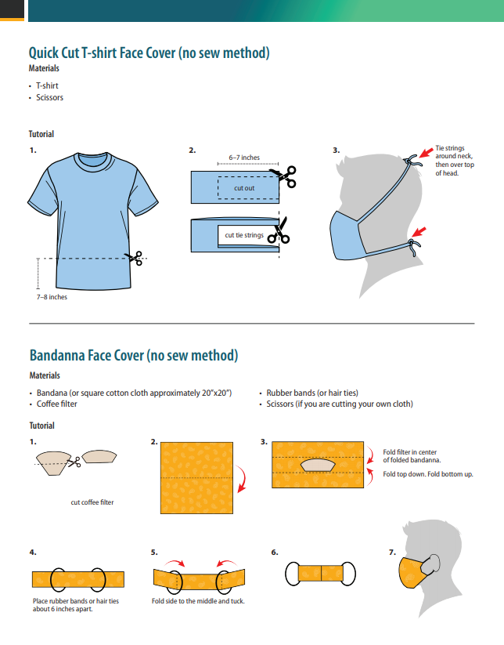

Jobsite Postings
CDC – Stop the Spread of Germs
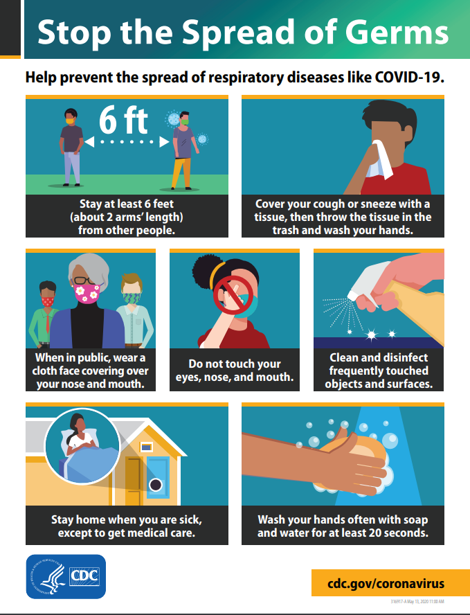

Jobsite Postings
Federal Required Poster
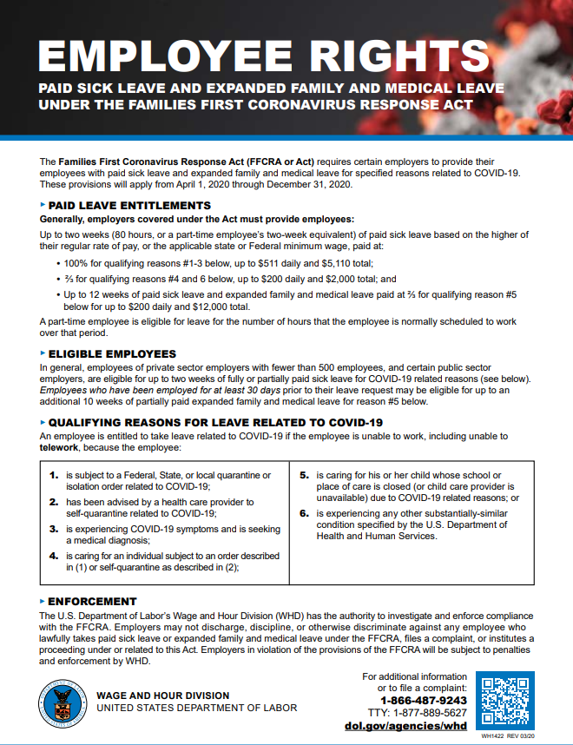

Jobsite Postings
CDC – Clean Hands

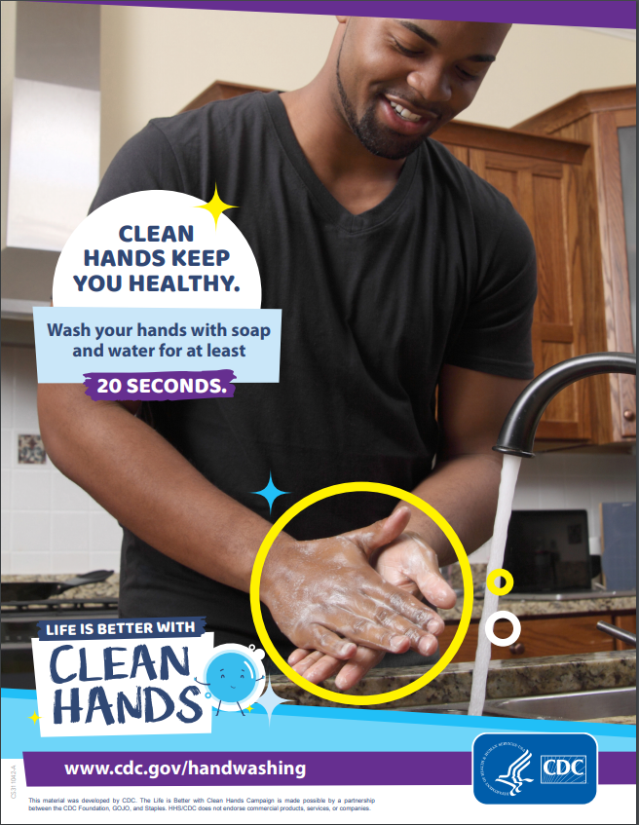

Jobsite Postings
CDC – Cover Your Cough
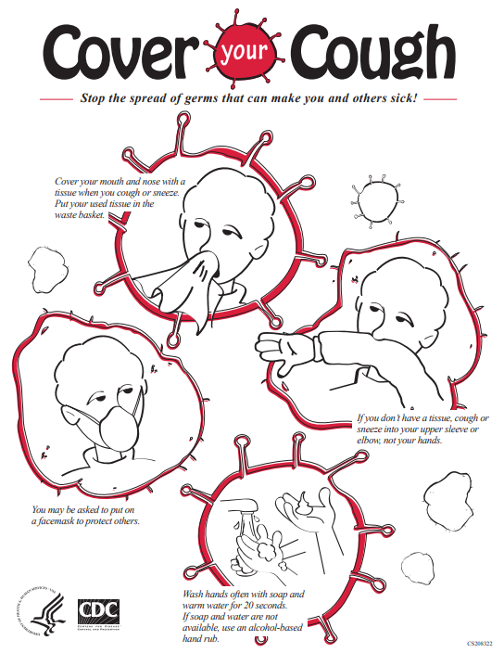

Jobsite Postings CDC – How to Remove Gloves
